Project Proposal

Online Bullying Education Web & Mobile Application

Student Name: Muhammad Asad Malik

Email address: [x14499662@student.ncirl.ie](mailto:x14499662@student.ncirl.ie)

Number: x14499662

Degree Programme Name: BSc (Hons) in Computing

Specialisation: Software Development

Date : 27/10/2018

# Objectives

The aim of this Project to develop web and mobile application on cyberbullying the application will have four main functionalities. Login, Educating on cyberbullying, commination forum and Quiz. The users will be able access the website but will not be able to access the forum and Quiz on till they signup and login. The Education on cyberbullying section users will be able to learn what is it online bullying, how to prevent it, what are the sign or how to recognize it and tips for teens, adult and parents. The Forum the users will be able to communicate with each other on different topic and system will automatically check for bad word remove bad comments in the forum. The Quiz section will have different types of Quiz’s, example: how well do you know cyberbullying and how to prevent cyberbullying Quiz and many others quiz’s

# Background

The purpose of doing this project stop cyberbullying as much as possible and help teens, adult and parents. know days almost everyone has some sort of device like mobile phone, laptop, tablet and others. Due to this people are harass and embarrass other people on internet non-stop like sending bad emails, texts, posting hurtful things about the person on social media, by creating fake profile and pretending to be that person, by putting embarrassing photo or video without the permission of that person then making fun of them with multiple people and spreading rumours about someone online they might not even meet in real life. (Anon., 2014- 2018)

My application will help different age group on how to recognize and prevent cyberbullying, with different topic for teens, adult and parents for their kids. The step by step guide line on different situation to protect themselves and alert them in future. The application will also provide Forum functionality where person who is getting bullied can talk to other people and find out the best solution to the problem. The web application will also have different Quiz’s to teach about cyberbullying. It will solve the problem of people who stay silence and suffer with anxiety, depression and low self-esteem and they don’t want to tell anyone what happened.

# Technical Approach

The web application login details and forum info will be store in SQL database, and the website design and layout will be done by using bootstrap and the application will be deployed on Heroku.

# Project Plan

This is my Project Plan below featuring a Gantt Chart.

The project plan has been divided in to six categories:

* Scope
* Software Requirements
* Design
* Development
* Documentation
* Closing

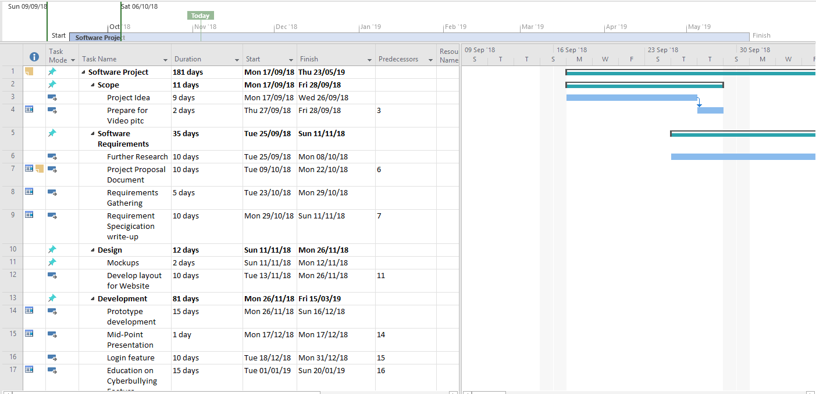

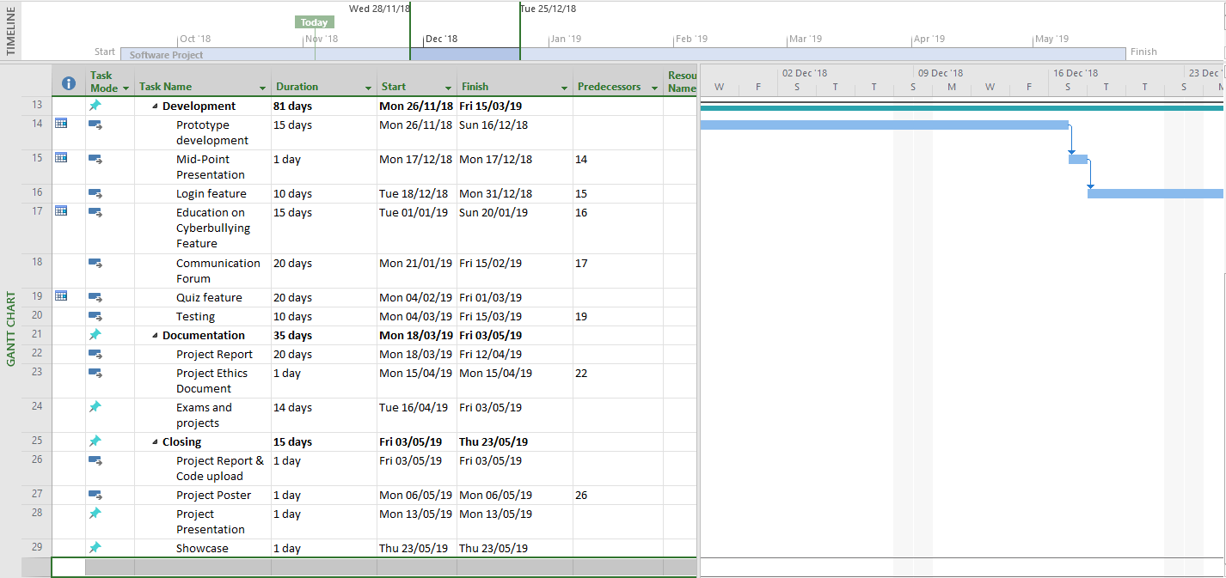

# Technical Details

## Proposed Technologies

* Bootstrap
* SQL Server
* MySQL
* PHP
* Xampp
* Heroku

# Evaluation

The web application will be used by different age groups and the system evaluate will be done getting the feedback from the users.